|  |  |  |  |
| --- | --- | --- | --- |
|  | | | |
| **Title*:** | PoC#2 Final Report | | |
|  |  | | |
| from **Source**\*: | University Carlos III de Madrid | | |
| Contact: | Marco Gramaglia | | |
|  |  | | |
| input for **Committee**\***:** | ENI | | |
|  |  | | |
| Contribution **For*:** | Decision |  |  |
|  | Discussion |  |  |
|  | Information | **X** |  |
|  |  | | |
| Submission date**\***: | 2019-07-10 | | |
|  |  | | |
| Meeting & Allocation: | - | | |
| Relevant WI(s), or deliverable(s): |  | | |
|  | | | |

**ABSTRACT:***This document reports on the PoC#2 activities, the achieved goals, and the future plans.*

ENI ISG PoC Report Template

# 1 General

The following normative disclaimer shall be included on the front page of a PoC report:

*Submission of this ENI ISG PoC Report as a contribution to the ENI ISG does not imply any endorsement by the ENI ISG of the contents of this report, or of any aspect of the PoC activity to which it refers.*

# 2 ENI ISG PoC Report

## 2.1 PoC Project Completion Status

* Overall PoC Project Completion Status: Completed

## 2.2 ENI PoC Project Participants

Specify PoC Team; indicate any changes from the ENI ISG PoC Proposal:

* PoC Project Name: **Elastic Network Slice Management**
* Network Operator/Service Provider: TIM Contact: Luca Pesando
* Manufacturer A: Huawei Contact: Wang Yali
* Manufacturer B: Samsung Contact: David Gutierrez-Estevez
* Additional Members: University Carlos III of Madrid Contact: Marco Gramaglia
* Additional Members: CEA-Leti Contact: Nicola di Pietro

## 2.3 Confirmation of PoC Event Occurrence

* PoC Demonstration Event Details: The PoC was showcased in two international events that took place in Turin (Italy) on May 24th, 2019 and Valencia (Spain) during the EuCNC conference in the week of June 17th- 21st . Photos of the 2 events and a press release for the Turin event follow.

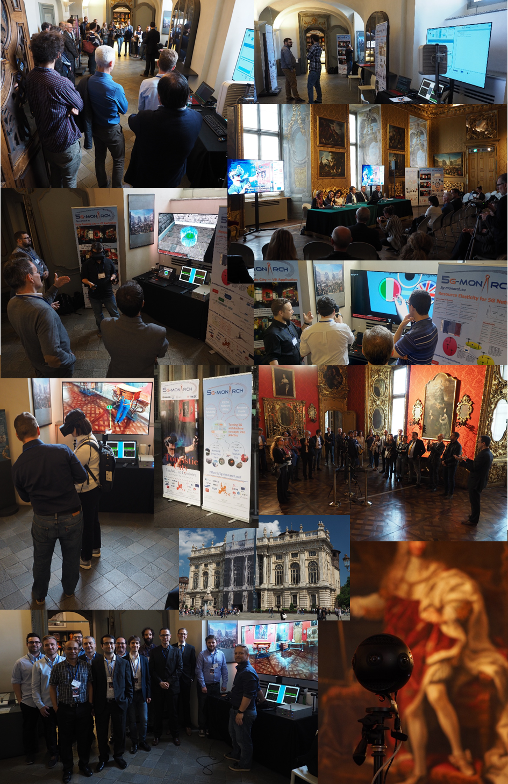

Figure Pictures from 5G-MoNArch event in Turin on May 24th, 2019

## 

Figure Pictures from the 5G-MoNArch presence at EuCNC 2019

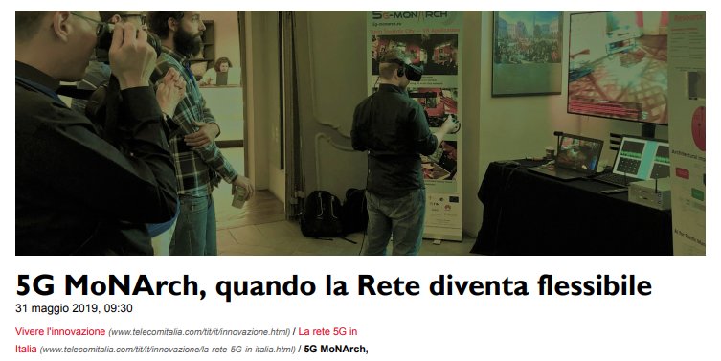

Figure TIM press release for the event

## 2.4 PoC Goals Status Report

According to the proposal, these were the specific projects goals:

*This PoC contributes to demonstrate ENI as a viable technology for the improvement of telecommunication networks. We intend to prove the applicability of the techniques described in ETSI GS ENI 001 [1] Use Case #2-6, “Elastic Resource Management and Orchestration”.*

*The main goal of this PoC consists in showing the feasibility and the benefits of an AI-assisted “elastic” management and orchestration of the network, which entails an improvement of the network efficiency and its capability to smoothly adapt the resource allocation and utilization. The public demonstration of these ENI concepts, based on an architectural framework compatible with ENI Reference Architecture ETSI GS ENI 005 [2], will help to build commercial awareness and confidence in the ENI approach.*

* PoC Project Goal #1: Demonstrate ENI as a viable technology for the improvement of telecommunication networks Goal Status (Demonstrated/Met?) Demonstrated

The implementation of the PoC followed as close as possible the spirit of the ENI architecture defined in [1], “with a specific module as compliant as possible with the ENI architecture defined so far. So, in order to implement the features envisioned by the testbed architecture described above, we rely on an orchestration architecture based on the Open Source MANO (OSM) orchestrator Release Four [2] and the OpenStack VIM [3].

OSM is one of the leading solutions for the implementation of a fully-fledged mobile network orchestrator, including several components for the automatic Lifecycle Management. Still, to provide the enhanced functionality needed, substantial changes to the OSM code and architecture are provided.

The Figure Below shows the OSM architecture, composed by several modules that carry out the different functionality needed by an orchestrator. However, it was also necessary to implement certain additions for supporting some features of elasticity and flexibility specific to this Po (they have not been pushed towards the OSM codebase, but they will be useful to understand the implications of the usage of ETSI ENI in conjunction with ETSI NFV MANO); they are the following:

**Resource Orchestrator:** this module provides the hooks towards different VIMs supported by OSM. In the context of the testbed, we use OpenStack as the main VIM to manage the local Network Function Virtualisation Infrastructure (NFVI) deployment.

**Network Service to VNF communications:** we extend this API (that is used to configure the VNFs in a chain) to allow more specific configurations (such as the ones needed by the radio network functions, which are PNFs) and support the VNF relocation.

***Network slice blueprinting:*** the slice blueprints and templates must be translated into descriptors that can be used by the OSM internal modules. For instance, certain parameters present in our blueprint were not explicitly managed by OSM.

**AI enabled orchestration module**: the specific algorithms such as the Admission Control and the Horizontal Vertical Scaling reside on top of the Service Orchestration module, to use the API specifically designed for that purpose. This module is a specific add on to OSM, tailored to the purposes of the testbed, implementing the AI architecture. This is the module that implements the ENI component as defined in [1].



Figure OSM Architecture [2]

*The PoC will demonstrate in a testbed environment how ENI can be used to integrate and improve the resource and network function management and orchestration, including slice admission control and deployment, horizontal and vertical scaling of virtual network functions, and their migration between different nodes of the network.*

* PoC Project Goal #2: Demonstrate the advantages of intelligent resource orchestration Goal Status (Demonstrated/Met?) Demonstrated

We evaluated the advantages brought by relocation, scaling and admission control under a number of KPIs as defined by the 5G-MoNArch project [4]. We elaborate on them in the following table.

|  |  |  |  |
| --- | --- | --- | --- |
| **KPI** | **Objectives (as in [4])** | **Testbed Measurements** | **Testbed Contribution to Project Objectives** |
| Area traffic capacity | Improvement by factor ~10  (5G-PPP target = 10) | By automatically scaling the VNF according to the real demands of the network slices, the wireless area capacity may be increased (in the sense that the same infrastructure can process basedband from more access points). By combining these results with the one available for the experiment driven optimization in [5], absolute figures may be drawn [4]. As a proof of concept, we can scale the higher layers and UPF machines of the eMBB slice to the double just when needed, duplicating the capacity on demand. | The measurements are aligned with the project objectives. |
| Service creation time | < 90 min | Yes. Both slices are successfully onboarded and configured in about 7 minutes. | The measurements are aligned with the project objectives. |
| E2E Latency | < 5 ms | As shown in the Figure below, when the elasticity algorithm is applied, the latency can be restored to sub 5ms levels |  |
| Relocation Delay | No disruption | As shown in the table below the elasticity algorithm can relocate VNFs within very few milliseconds, avoiding service disruption |  |

## 

Figure The overall E2E delay

One of the fundamental functionalities needed by the PoC is to guarantee low latency for the user attached to the URLLC slice. Otherwise, the haptic interactions between the tourist and the guide may rapidly degrade to unacceptable levels, harming the overall VR experience. We have thus evaluated the improvement in the latency KPI on the URLLC network slice.

In particular, we have evaluated latency in a scenario where we have emulated the different latency between the two clouds by inserting a delay on the TN with the Linux traffic shaper command. In this scenario, we leverage the orchestration functionality of the PoC to place close those functions which have an impact on latency, in the edge cloud (i.e., close to the end-user), with the goal of meeting the user’s stringent latency requirements. In this context, we measured the E2E delay between the UE and the UPF. The result, averaged over 50 repetitions, is depicted in Figure above.

## 2.5 PoC Feedback Received from Third Parties (Optional)

* Where applicable, provide in a free text, feedback received from potential customers, Ecosystem partners, event audience and/or general public.

The service implemented in the testbed has been deployed with the goal of providing an added value for the visitors of the museum (see [6] for the complete definition of the use cases related to this PoC). Thus, the monetization of this service would be linked to its exploitation by the museum operator (in this case, Fondazione Torino Musei). It is important to highlight that these partners were already actively involved in the development of this testbed and has showed interest in continuing its use after the end of the project. Also, in the tests with real users, a questionnaire was provided to them asking about their willingness to pay a higher museum entrance in exchange of this improved experiences.

# 3 ENI PoC Technical Report (Optional)

## 3.1 General

PoC Teams are encouraged to provide technical details on the results of their PoC using the PoC Scenario Report template below.

## 3.2 PoC Contribution to ENI ISG

Use table B.1 to list any contributions to the ENI ISG resulting from this PoC Project.

Table 1

|  |  |  |  |
| --- | --- | --- | --- |
| Contribution | WG/EG | Work Item (WI) | Comments |
| feasibility of Horizontal and Vertical VNF Scaling |  | ETSI GR ENI 005 | We could successfully test horizontal and vertical scaling of VNFs (an UPF in this case), by using AI triggered by CPU measurement |
| Feasibility of admission control |  | ETSI GR ENI 005 | *We tested the admission control algorithm with a pre-trained model tailored for the size of our testbed.* |
| Reporting on the Testbed showcase |  |  | The general public and the stakeholders that participated in the Turin and Valencia events were impressed by the usage of AI to automatically manage the network. From the questionnaire we collected, we obtained a positive feedback on this features, especially from vertical |

## 3.3 Gaps identified in ENI standardization

Use table B.2 to indicate Gaps in standardization identified by this PoC Team including which forum(s) would be most relevant to work on closing the gap(s).Where applicable, outline any action(s) the ENI ISG should take.

Table B.2

|  |  |  |  |  |
| --- | --- | --- | --- | --- |
| Gap Identified | Forum (ENI ISG, Other) | Affected WG/EG | WI/Document Ref | Gap details and Status |
| Interface and Architecture definition | ENI |  | ETSI GR ENI 001 | *The realization of this PoC and the implementation of the related algorithms and functional blocks has been insightful and allowed to highlight the gaps of the current architectural definition with respect to the state of the art open source software. The PoC team will contribute to the definition of the interaction between ETSI ENI and MANO by leveraging on this experience* |

## 3.4 PoC Suggested Action Items

## 3.5 Additional messages to ENI

## 3.6 Additional messages to Network Operators and Service Providers?

# References

[1] ETSI DGS/ENI-005 (GS ENI 005), “Experiential Networked Intelligence (ENI); System Architecture” v.0.0.25 Release 1

[2] OSM Release 4 <https://osm.etsi.org/wikipub/index.php/OSM_Release_FOUR>

[3] OpenStack <https://www.openstack.org/>

[4] 5G MoNArch D6.2 – “Methodology for verification and validation of 5G-MoNArch architectural innovations”

[5] 5G MoNArch D2.1 – “Baseline architecture based on 5G-PPP Phase 1 results and gap analysis”

[6] ETSI ENI PoC#2 Elastic Network Slice Management ENI(18)000175r4